**System Interconnections in Simulink**

**Lab 07**

Submitted by**:**

**Maaz Habib**

Registration Number**:**

**20PWCSE1952**

Section:

**C**

Submitted To**:**

**Dr. Muniba Ashfaq**

January 31, 2024

**Department of Computer System Engineering**

**University of Engineering and Technology Peshawar**

**Lab 07**

**Series System Interconnection**

**Find the equivalent system of the following systems connected in series. Prove it using Simulink.**

G1(s) = 1/(S+1);

G2(s) = 1/(s+4);

G3(s) = (s+3)/(s+5)

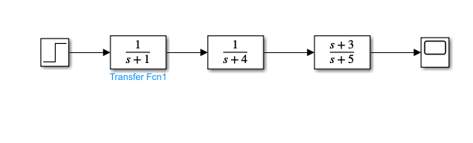

**Equivalent System**

In order to find the equivalent system multiply the transfer functions. So the equivalent system would be as follows.

G(s) = (s+3)/ (s3 + 10*s2 + 29*s + 20)

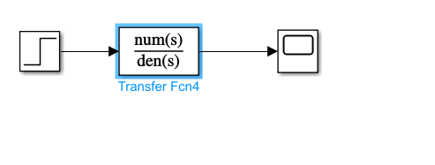

**MATLAB Code**

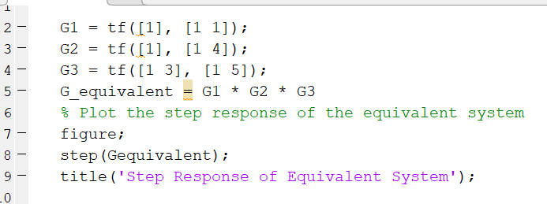

**Output**

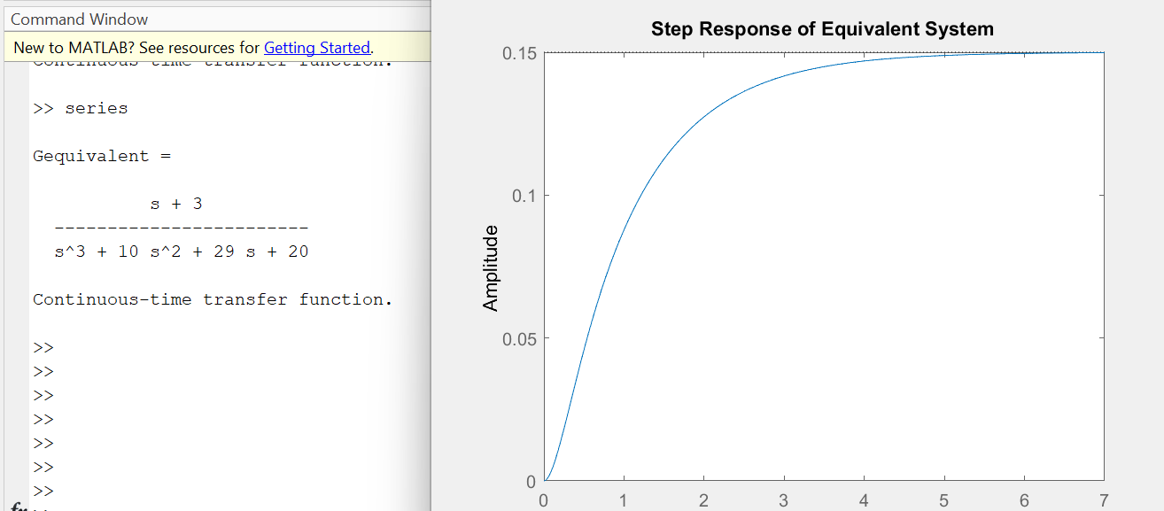

**Parallel System**

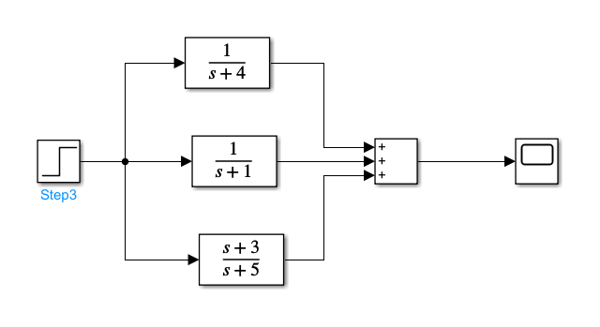

**Equivalent System**

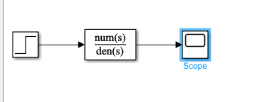

**MATLAB Code**

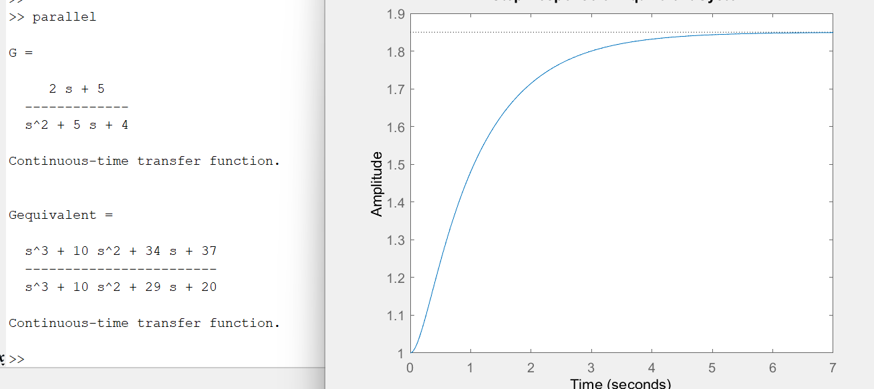



**Negative feedback system interconnection:**

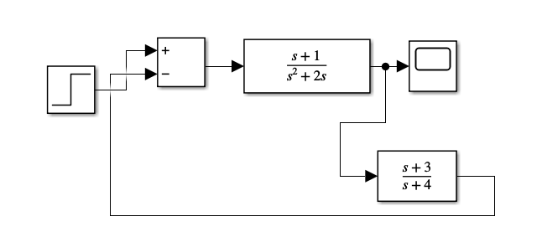

**Output**

**Equivalent System:**



**MATLAB Code**

**Output**

**Complex Interconnected System**

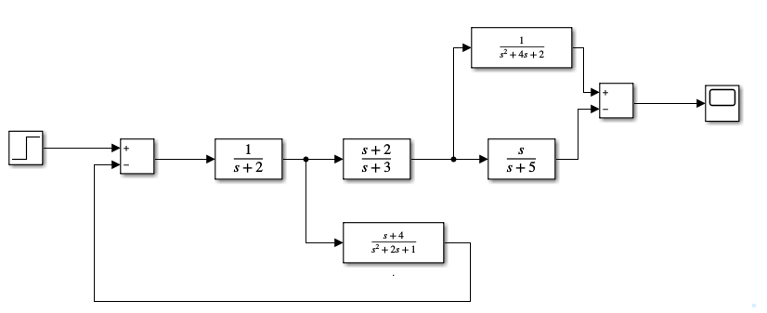

**Output**

**Equivalent System**

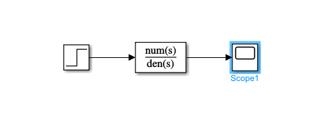

**Matlab Code**

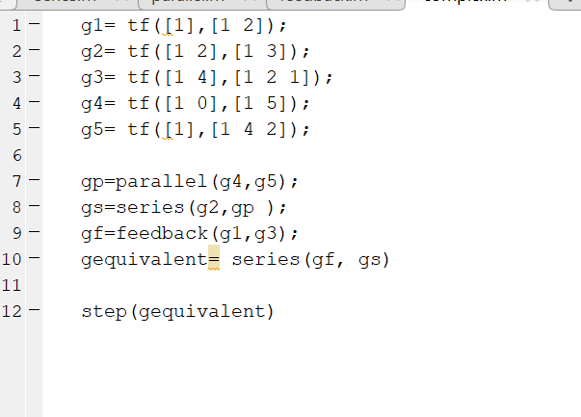

**Output**

